Experiment-12

Cursors

* Create a table with attributes students and marks
* Insert values into tables

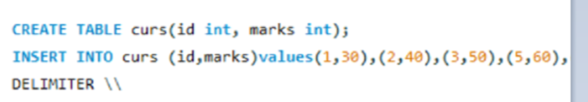

* Create a procedure and fetch the marks of given id using a cursor

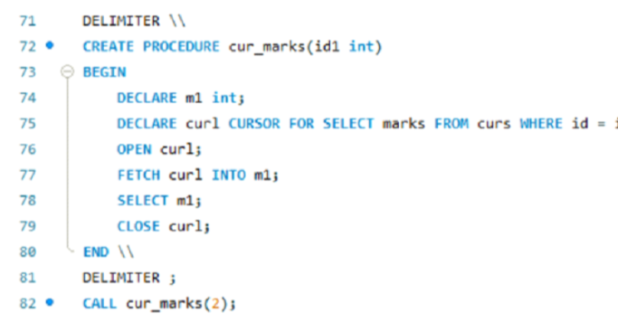

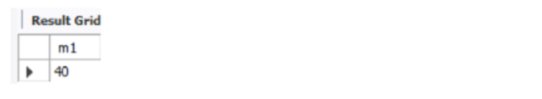

* Create a procedure and fetch the highest marks using a cursor

